Math 8 Unit Overview - Tessellations
Unit Name: | Tessellations
Duration: | 2.5 Weeks
Project Idea: | Students will present tessellation math pieces in a tessellation Art gallery for viewing by the entire school
IRP Standards: | demonstrate an understanding of tessellation by  − explaining the properties of shapes that make tessellating possible  − creating tessellations  − identifying tessellations in the environment
21st Centuary Skills Assessed and taught  (will be used for effort assessment) | - Creating art by use analyzing design and mathematics  - Critical Thinking  - Use of computers to generate mathematical art
Driving Question: | How is math aesthetically beautiful?
Further Questions that focus on the IRP standards: | See Appendix A for submission requirements for the tessellation art gallery
Major Products and Performances | Group: | As a class students will create an art gallery for the school.
 | Individual: | Students will need to hand in set of four tessellations to be used in the art gallery. See appendix A for details
Entry Events/Lessons | Day 1 | Discuss what is a tessellation and the concept of math as beautiful  -Reveal the project to the students  -Show examples from previous years doing the tessellation art gallery
 | Day 2-9 | Students get independent class time to work on their four tessellations
Reflection methods | - Students will self rubric and discuss how the art gallery went for them

Appendix A - The Assignment as Posted on the Wikipage

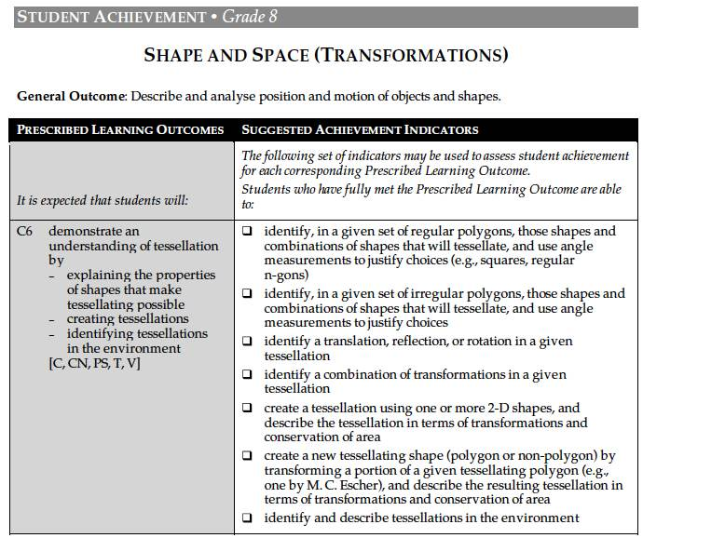
Mr. Garde's tessellation art exhibit requires four tessellations that are to be handed in by Friday May 25th
All tessellations must be presented in a frame. There are two frames that you can make
15 cm x 15 cm or 22 cm x 14.5 cm. Examples shown in Mr. Arca's room
1. A hand drawn (cut out shape and print) of a regular polygon that has been translated, reflected or rotated
2. A second hand drawn (cut out shape and print) of a regular polygon that has been translated, reflected or rotated - must be different from #1
(i.e. if you chose a translation in #1, you must do a reflection or rotation for #2)
3. A black and white photograph of something that you shot and has a tessellation. Expand and crop the photograph so it fits a frame
4. A computer generated tessellation of your choice.
5. Bonus for an art work that incorporates math and art.
Note for all art works, a plaque must be also given that:
a) has a title
b) explains the math that is used
c) your name
d) typed
There will be two marks given, one for math and the other for art
Math for Mr. Arca /6. One point five (1.5) marks for handing in each of the four tessellations - I'm looking for neatness, beauty and math explained
Beauty : /4 Beauty, art work.

